**Network and System Administration – Project**

**VirtualBox Installation**

* First, we need to download Virtual Box:

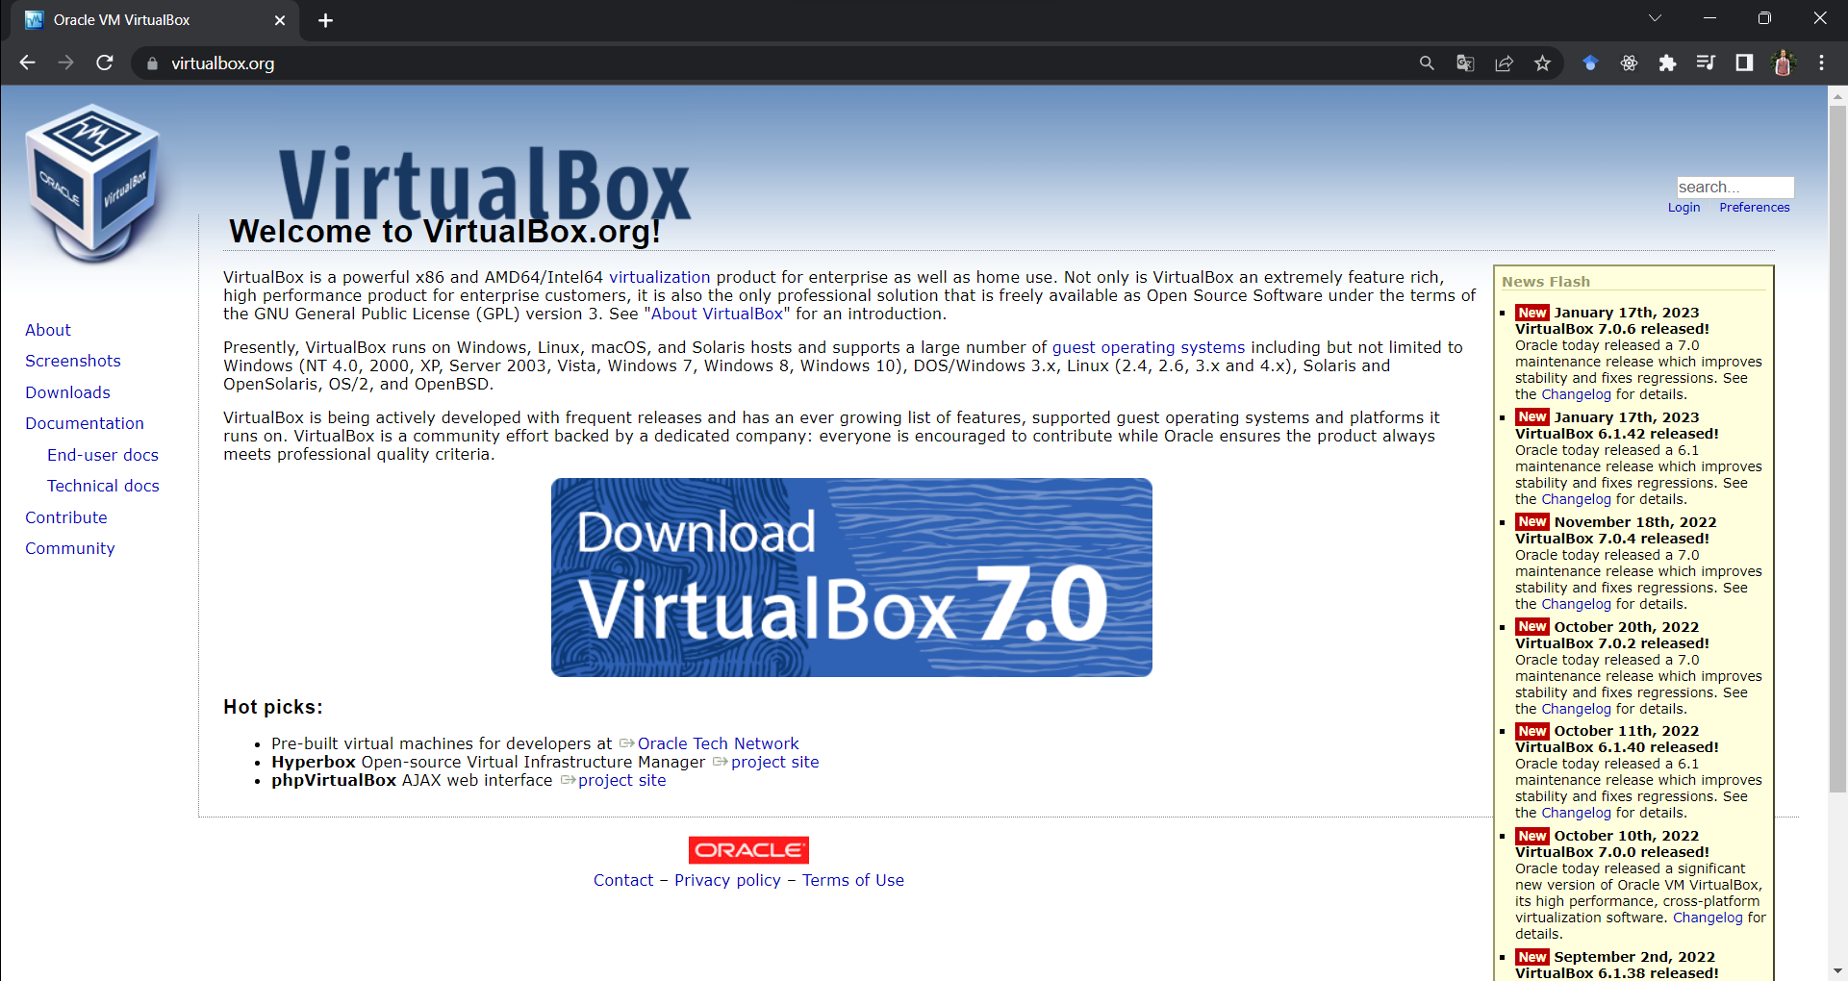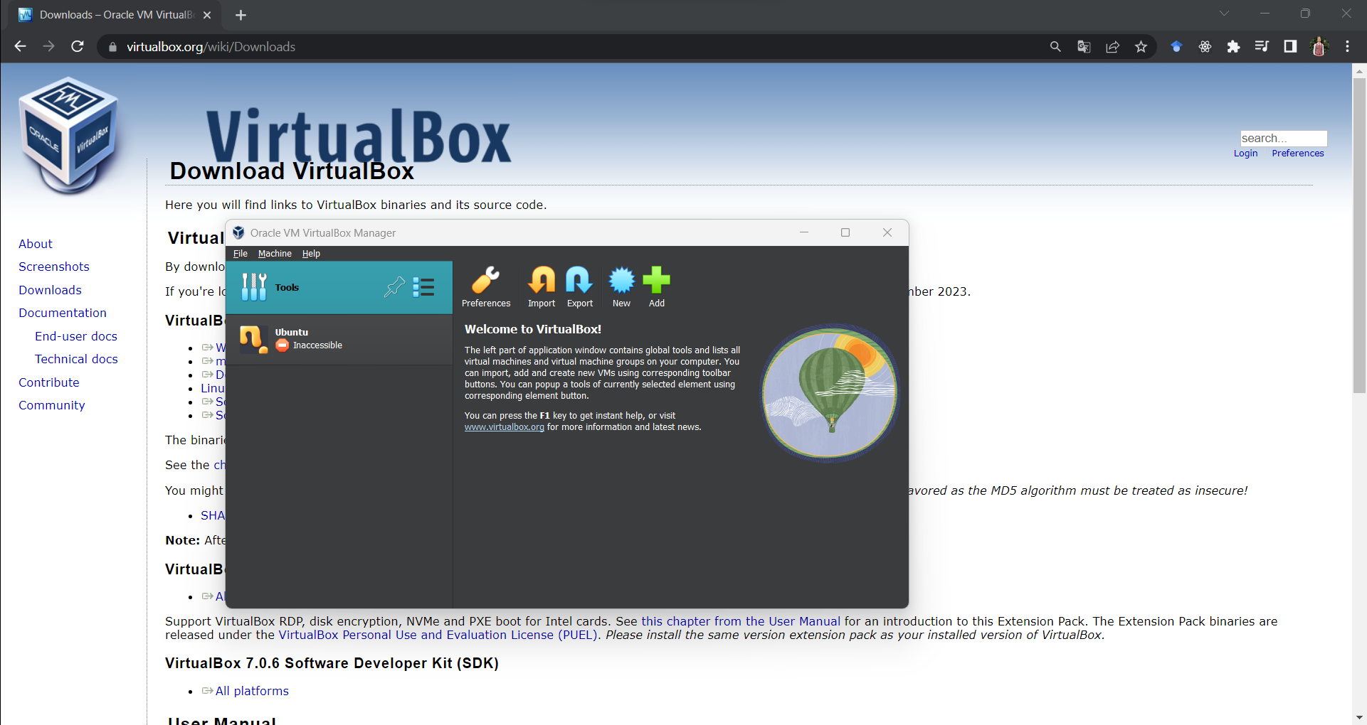

**Ubuntu Server Installation**

* Then, we can install different OSs on it.
* Ubuntu Server Basic Installation:

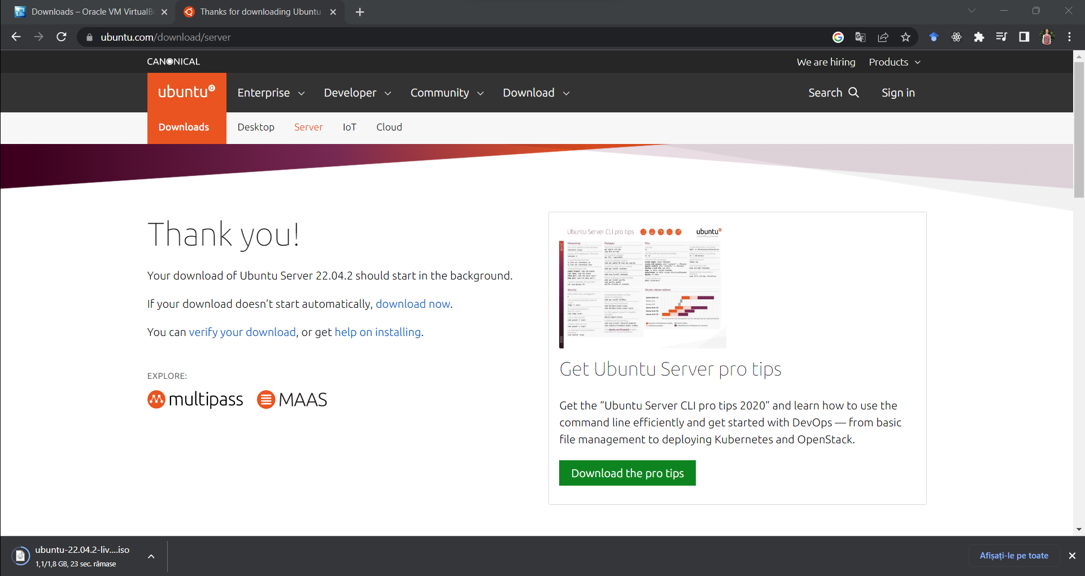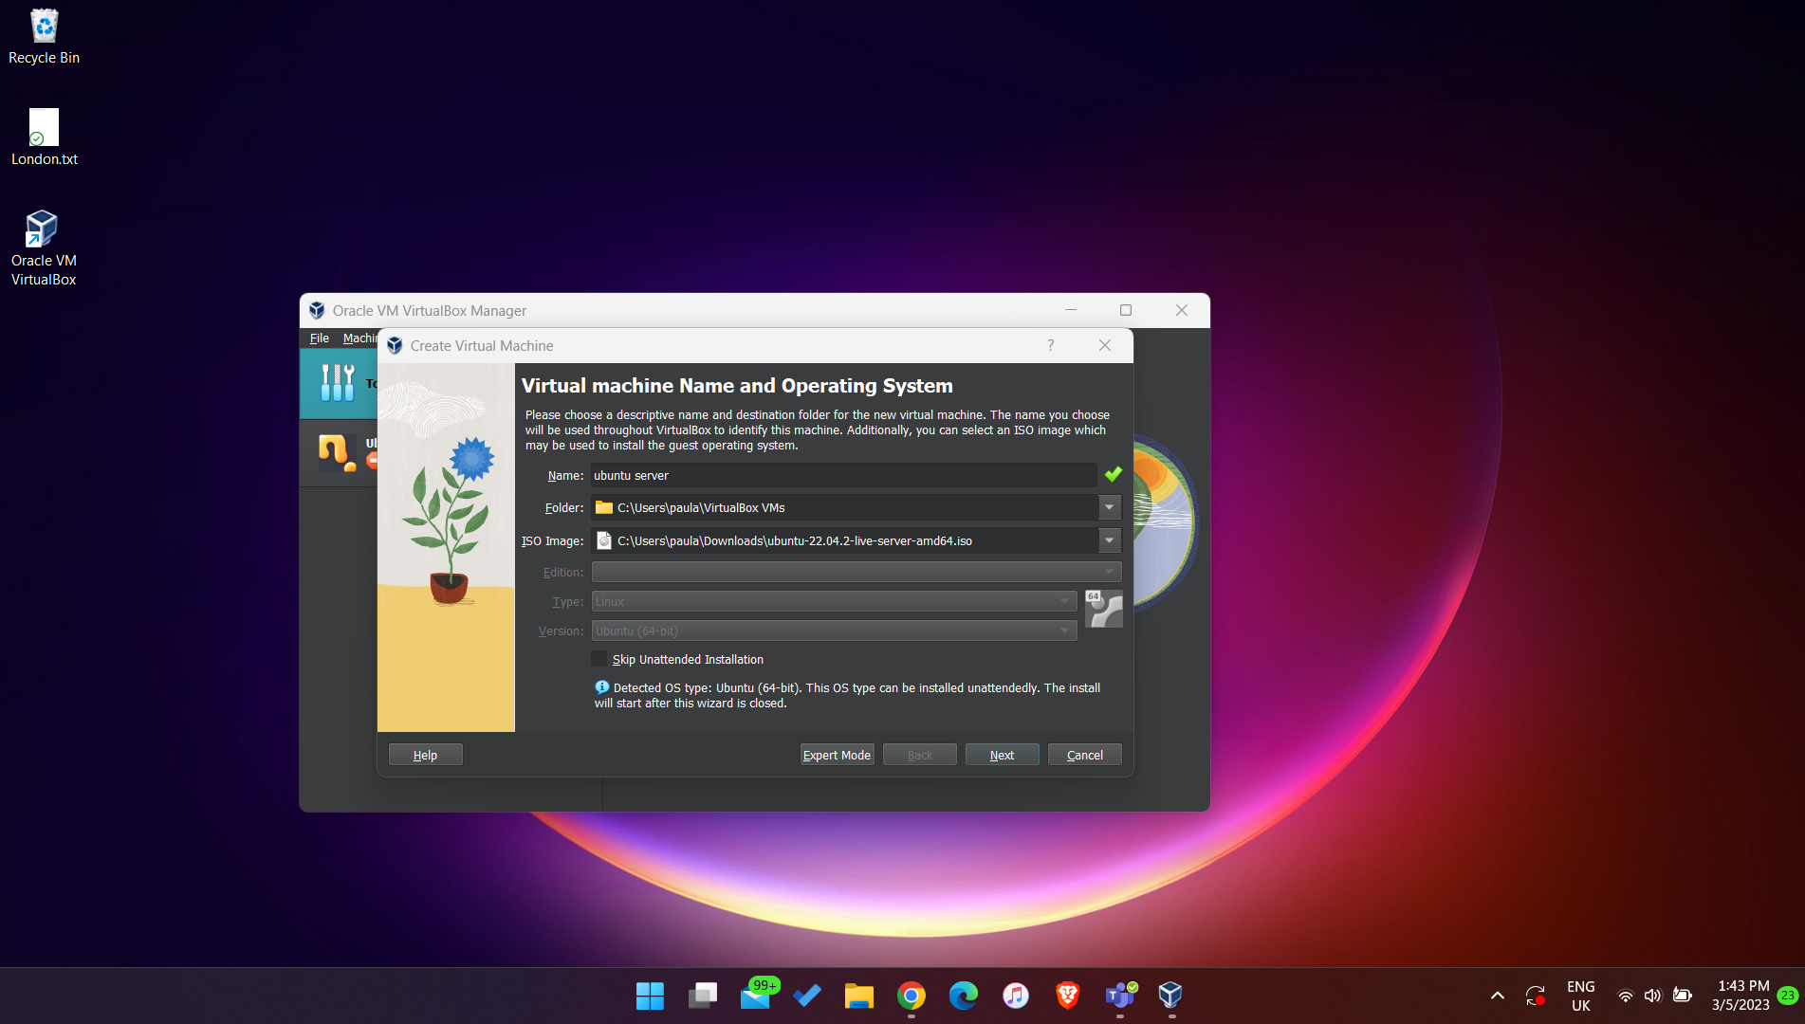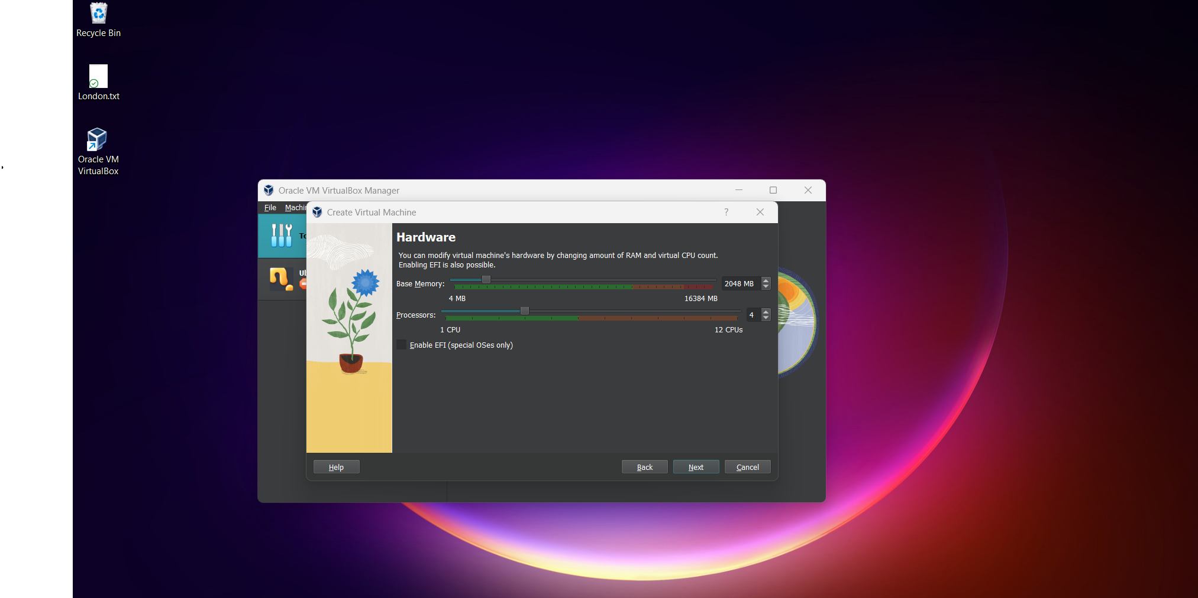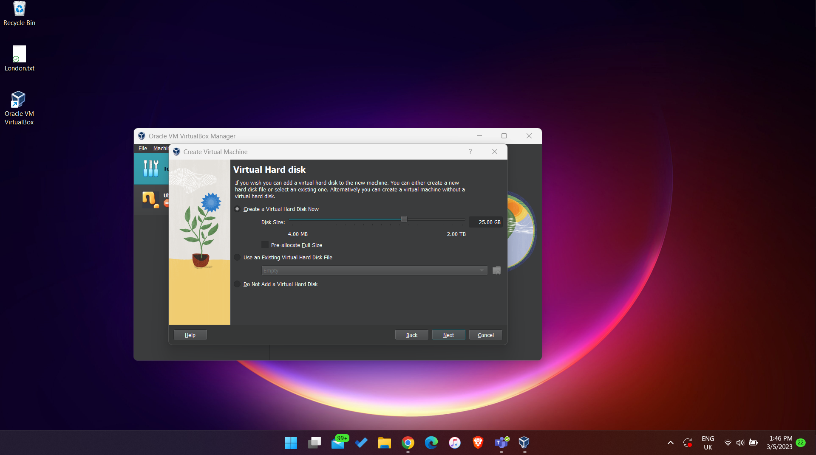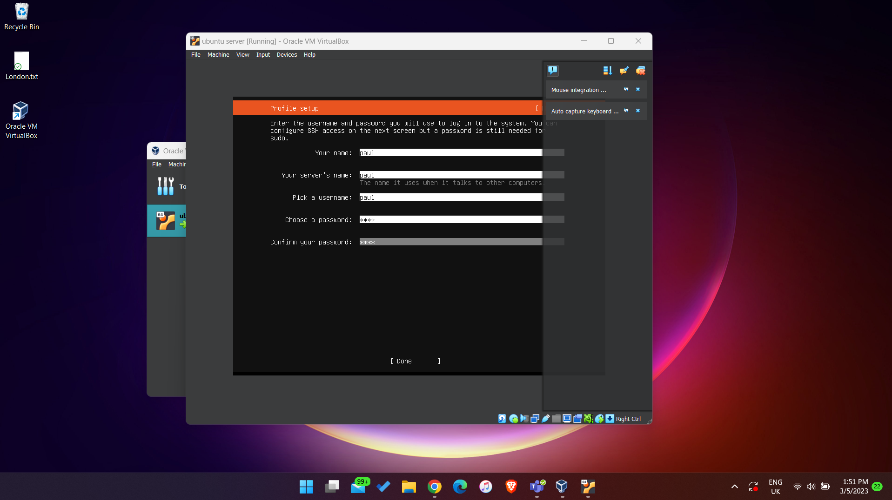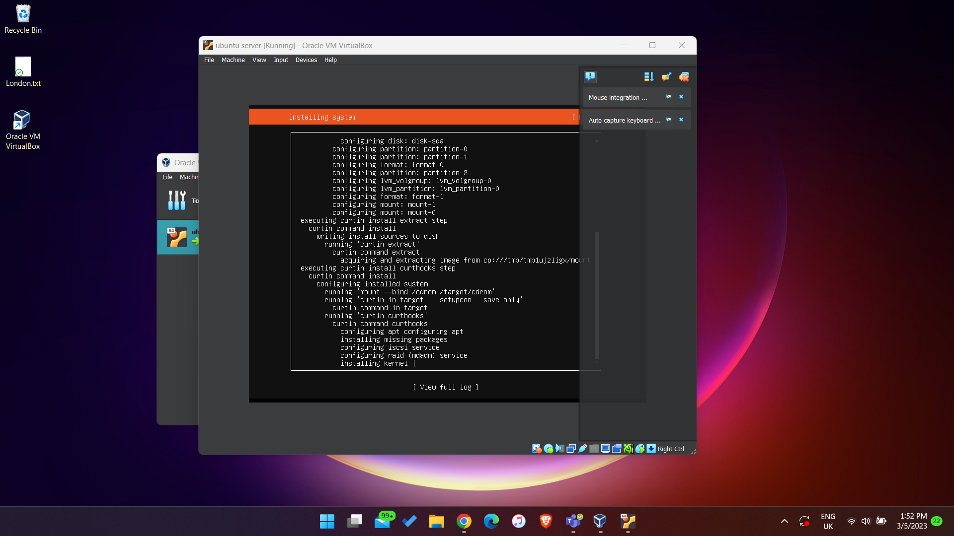

* We change the Virtual Network Adapter to Bridged Adapter, such that the VM will have an IP address in the same network class as our machine:

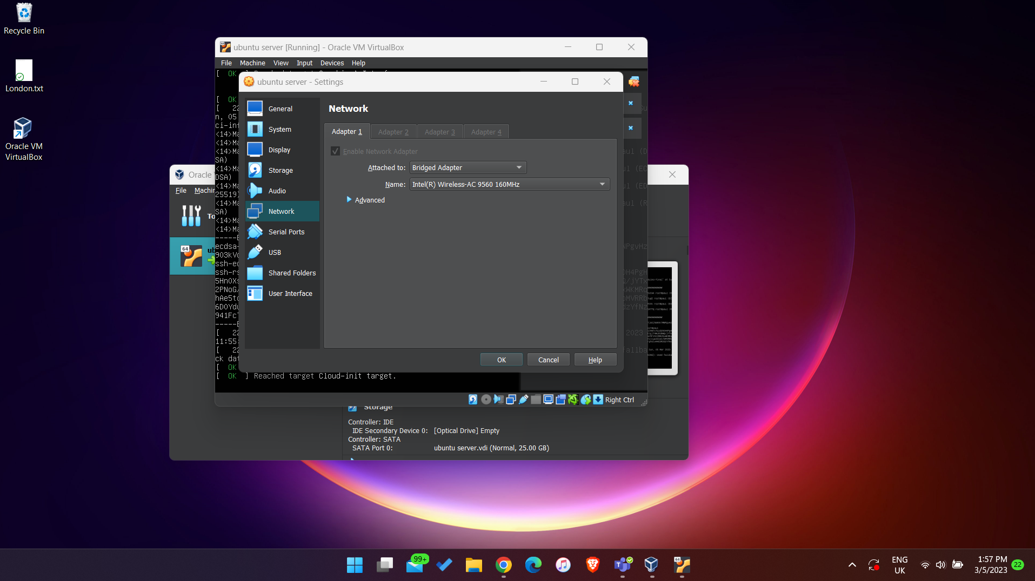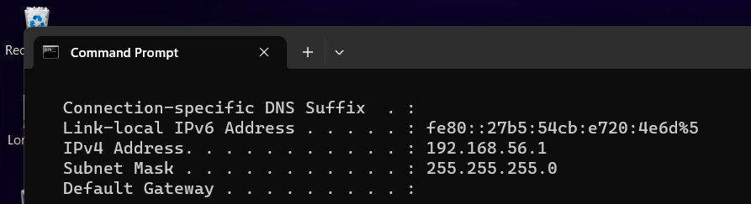

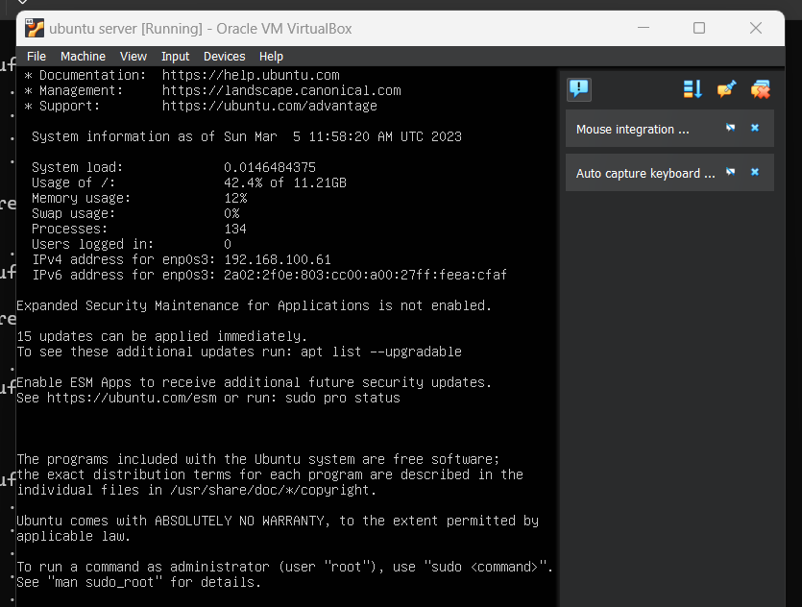

* We will connect to the Ubuntu Server from Putty later.

**Windows 7 Installation**

* I also installed Windows 7 Ultimate on the VM:

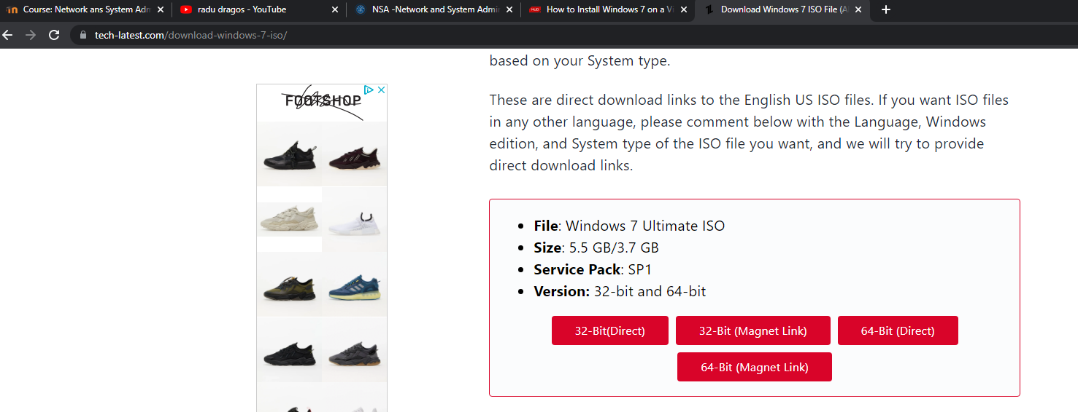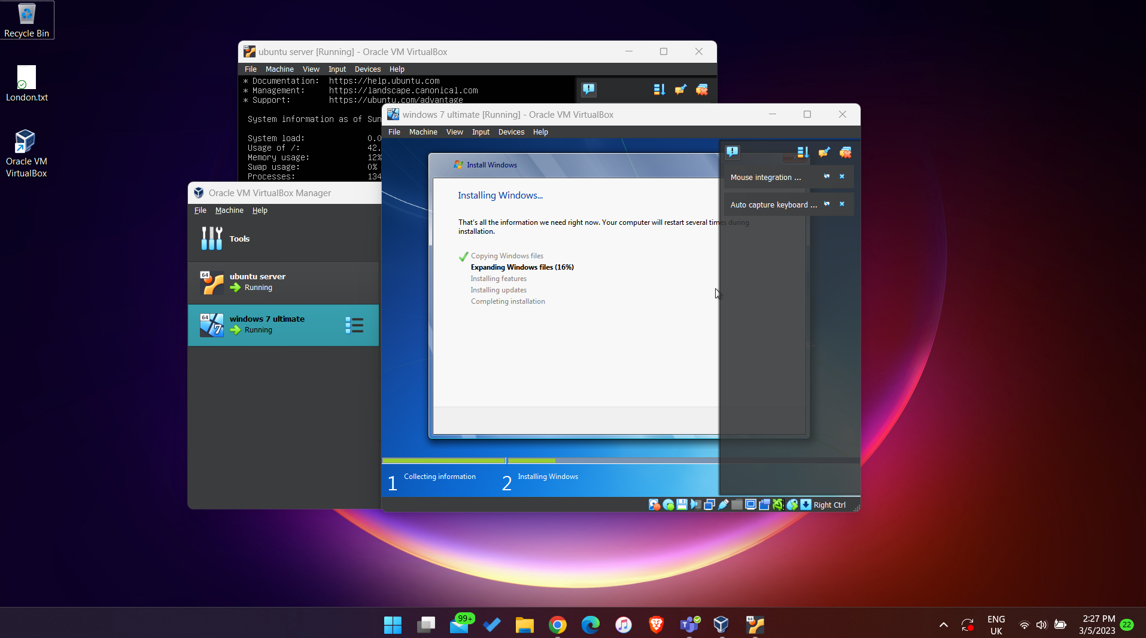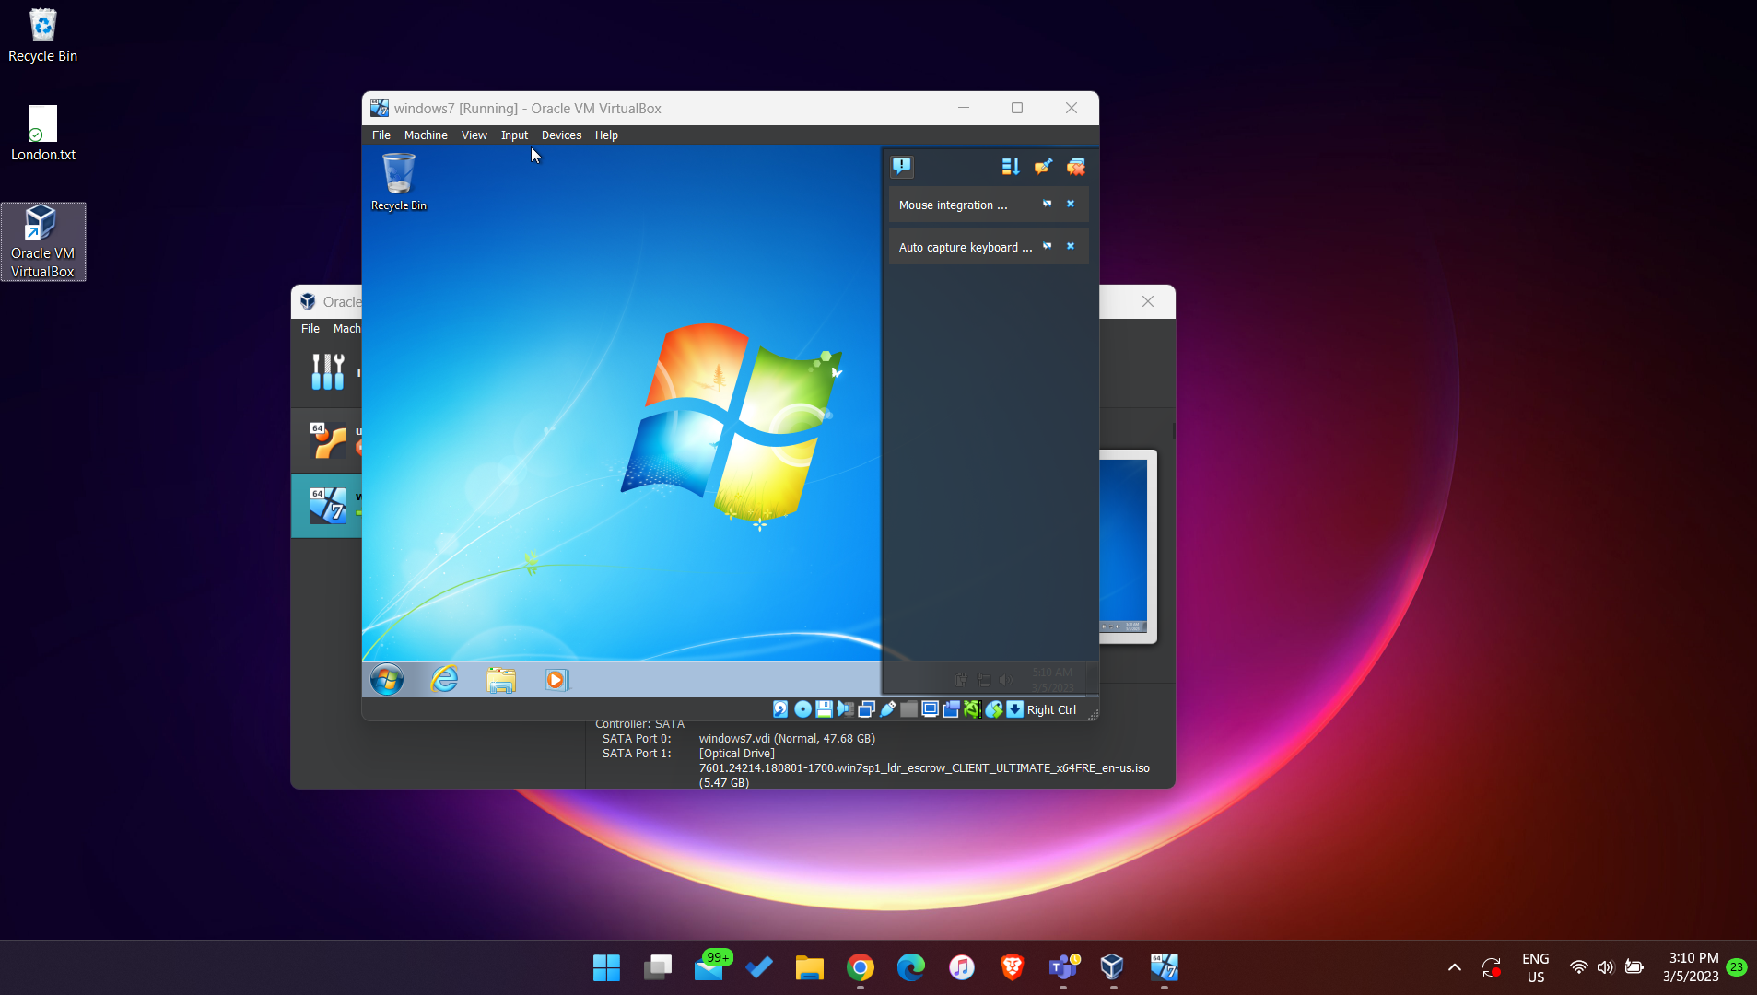

**Install and Connect to OpenSSH Server**

* First, we update the sources, then we install OpenSSH with the following commands:

~$ sudo apt update_

~$sudo apt install openssh-server

* We can check with the command “ifconfig” the IP address of the server (we use it in order to connect to it with Putty):

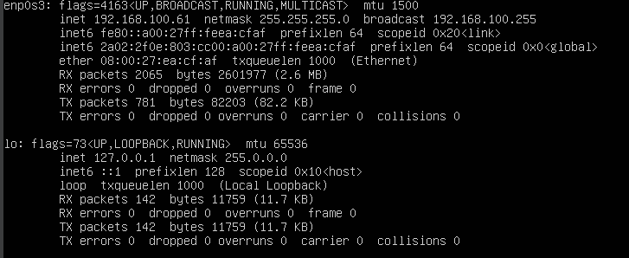

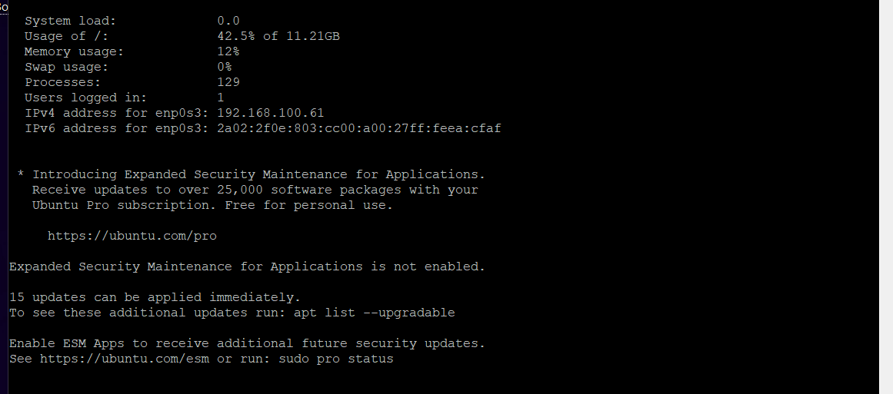

* We can check that SSH works with the following command:
* ~$ sudo netstat -ltnp

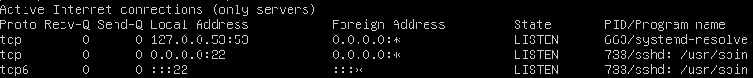

**SCP File Transfer**

* First step is to install WinSCP:

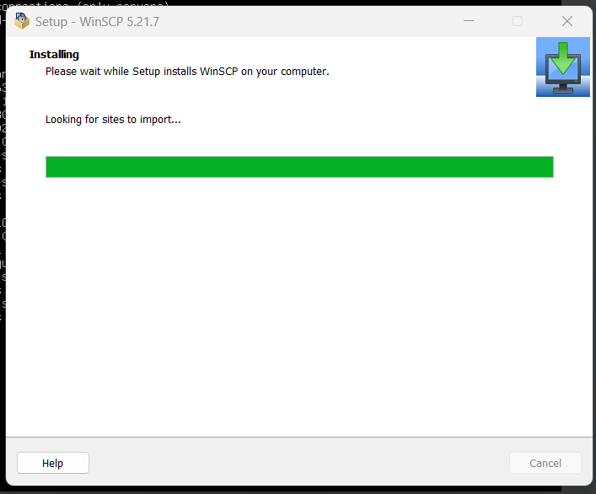

* Then, we will connect to Ubuntu’s IP address:

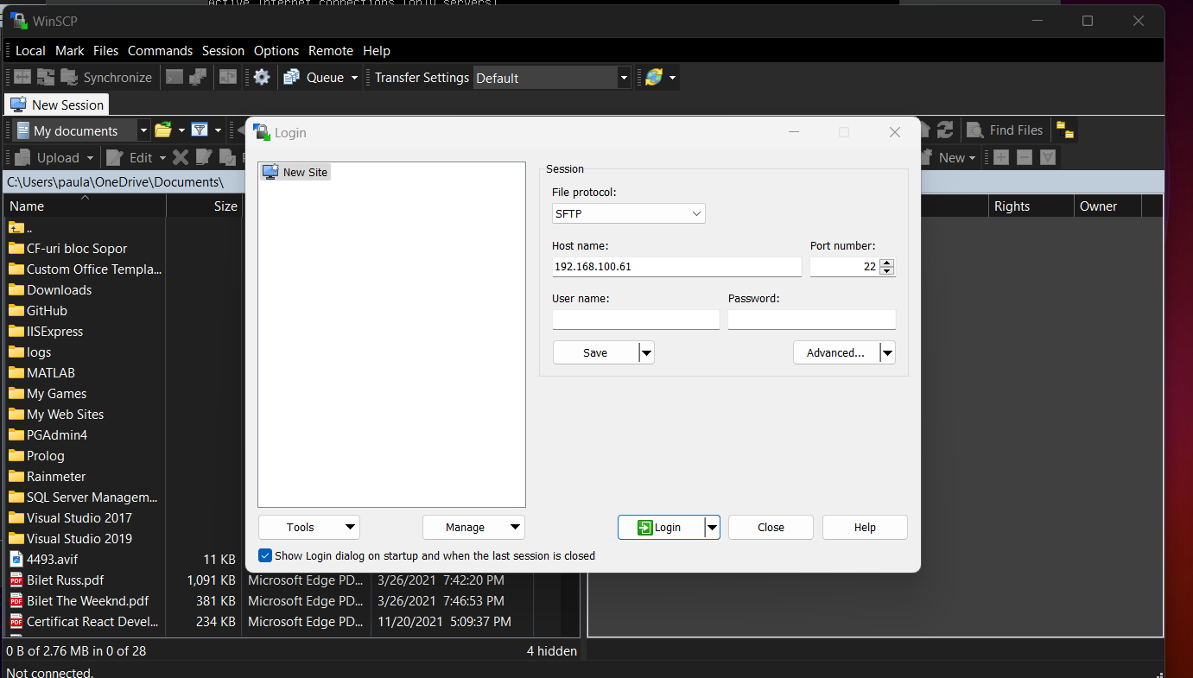

* Now we can transfer documents from our machine to the VM:

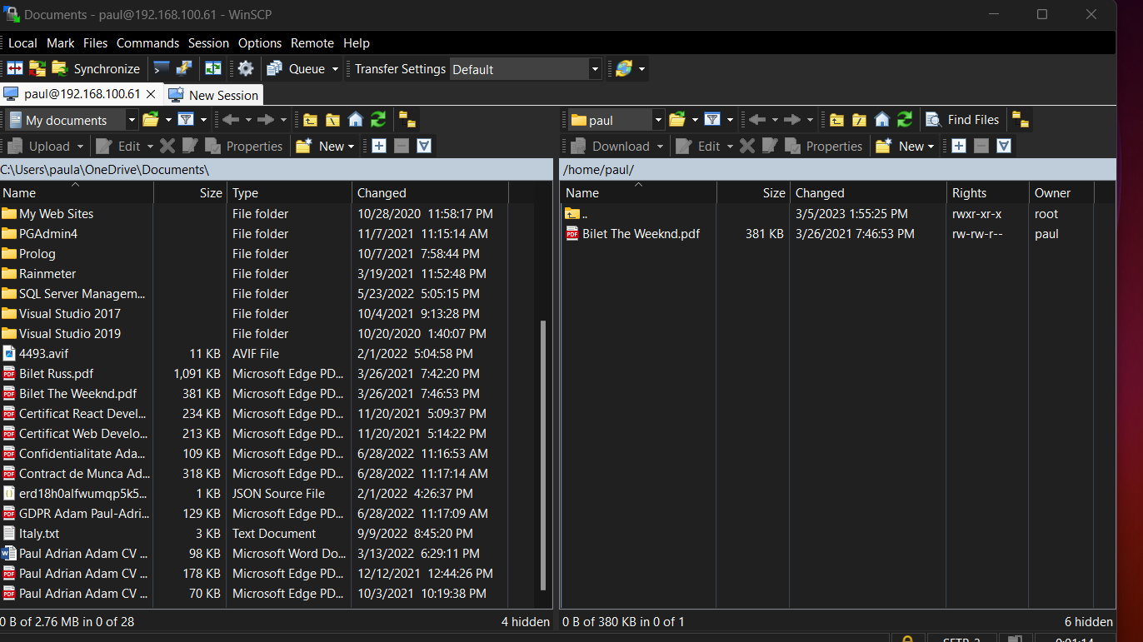

* Check that the document can be found on Ubuntu.

**LAMP**

* First, I will make myself a super user (such that I don’t need to write sudo anymore):
* ~$ sudo su -
* Install LAMP with the following command:
* ~# apt install lamp-server^_
* Navigate to Ubuntu’s IP Address from the local machine in order to check that the LAMP server is correctly installed:

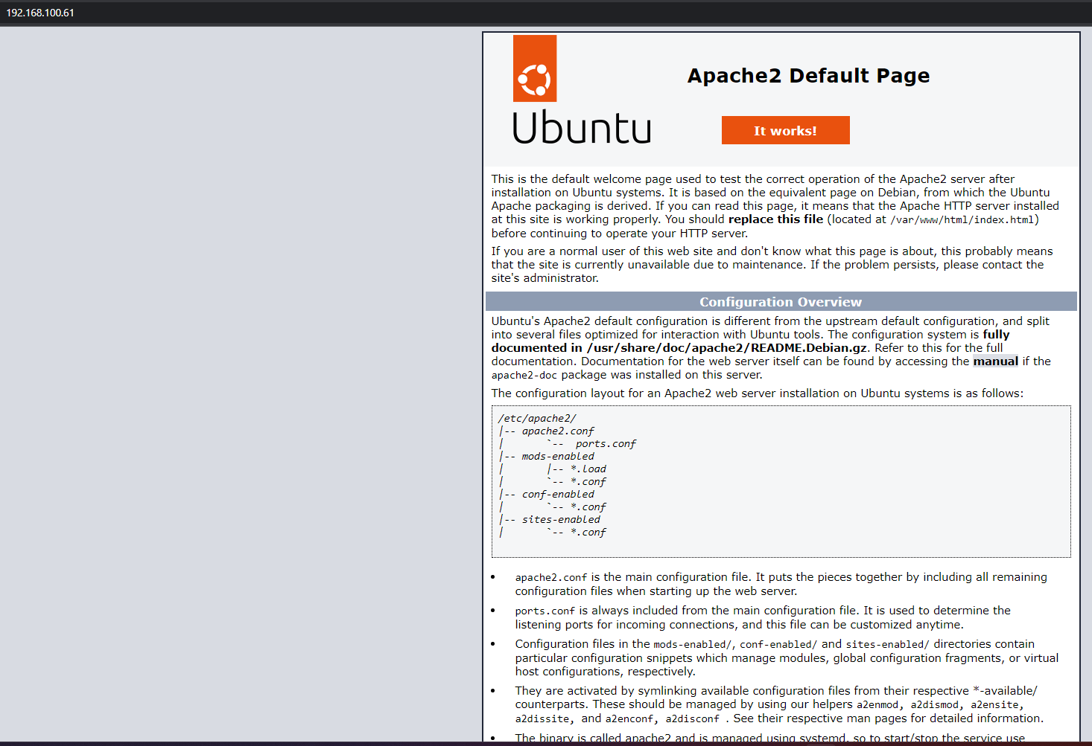

* Check PHP’s version:
* ~# php -v
* Update the default page:
* ~# cd /var/www/html/
* /var/www/html# ls
* /var/www/html# echo page >index.html

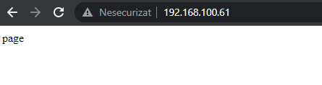

**Ubuntu as a Mail Server**

* Install Postfix as a mail server for Ubuntu:
* /# apt install postfix
* Verify that Port 25 is open and waiting for connections:
* /# netstat -ltbp

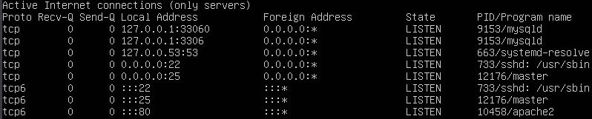

* Connect to TCP Port 25 by using telnet, then send a fake email:
* /# telnet localhost 25

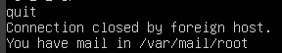

* Check that the email was received:
* /# cat /var/mail/root
* Another solution can be to use the command “mail” in order to send emails:
* /# apt install mailutils
* By using just the command “mail” we can choose what email to read:
* A more advanced way would be to use “alpine” (it has a user friendly interface):
* /# apt install alpine

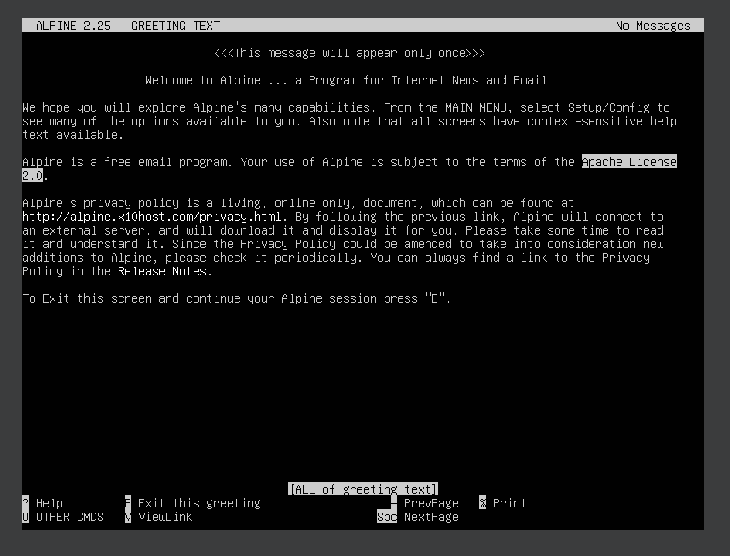

**Install FTP Server on Ubuntu**

* First, we need to install vsftpd (FTP Server):

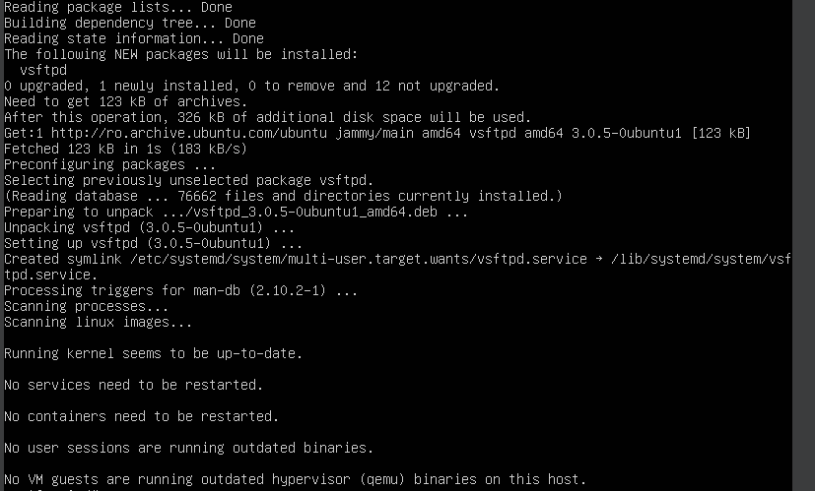

* We can check the status of an FTP Service with the following command:
* /# service vsftpd status
* Configure FTP Server:
* /# nano /etc/vsftpd.conf

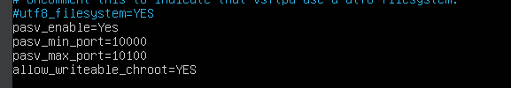

* The FTP Server listens to Port 20, with the following command we configure the traffic rules over the firewall:
* /# sudo ufw allow from any to any port 20,21,10000:10100 proto tcp
* Now, we need to restart the FTP Service:
* /# systemctl restart vsftpd
* Run the “ftp” command followed by the server IP to test the FTP connection:
* ftp 192.168.100.61

**Install DHCP Server on Ubuntu**

* Install the DHCP Server with the following command:
* /# apt install isc-dhcp-server
* Open the configuration file for the DHCP and add your network interface and other options such as the subnet address and the IP range:
* /# vi /etc/default/isc-dhcp-server

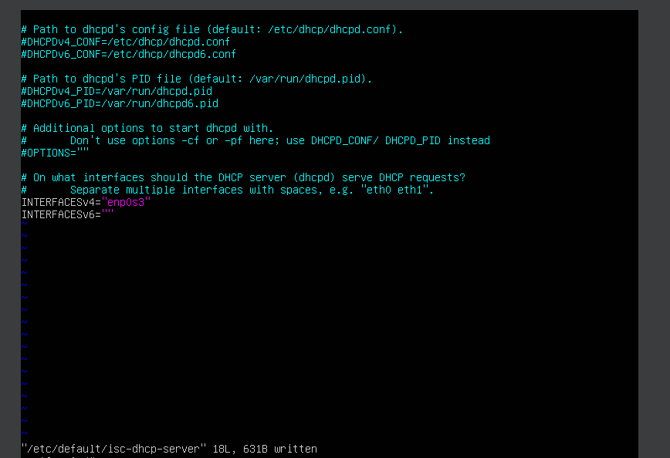

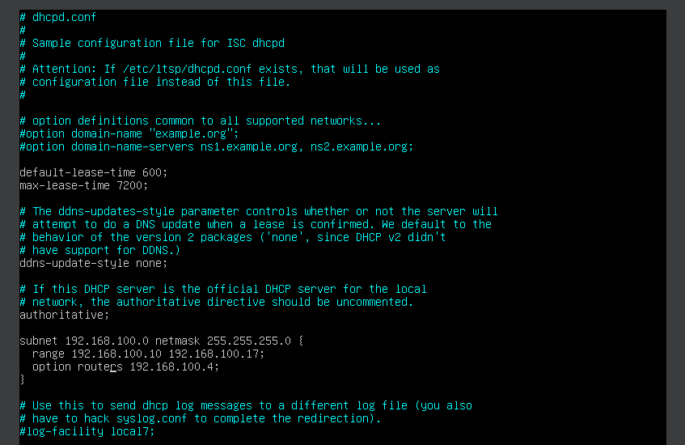

* This were calculated using “ipcalc”:

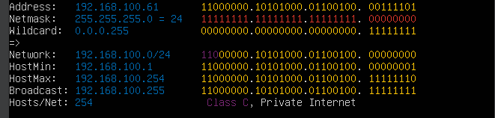

* Next, start and enable the DHCP server:
* /# systemctl start isc-dhcp-server
* /# systemctl enable isc-dhcp-server

**Install Squid Proxy for Private Connections on Ubuntu**

* First, install Squid Proxy with the following command:
* /# apt install squid
* Check that the server is running properly:
* /# systemctl status squid.service
* Change the configuration file such that Squid will allow clients to connect to it:
* /# nano /etc/squid/squid.conf

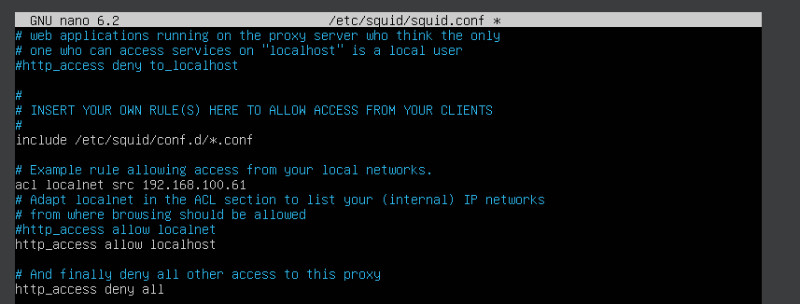

* Install Apache project in order to have access to a password generator that Squid likes, then use the “httpasswd” command in order to generate a password for a new Squid user:
* /# apt install apache2-utils
* /# htpasswd -c /etc/squid/passwords deni
* /# cat /etc/squid/passwords
* Update Squid’s configuration to use the new /etc/squid/passwords file:

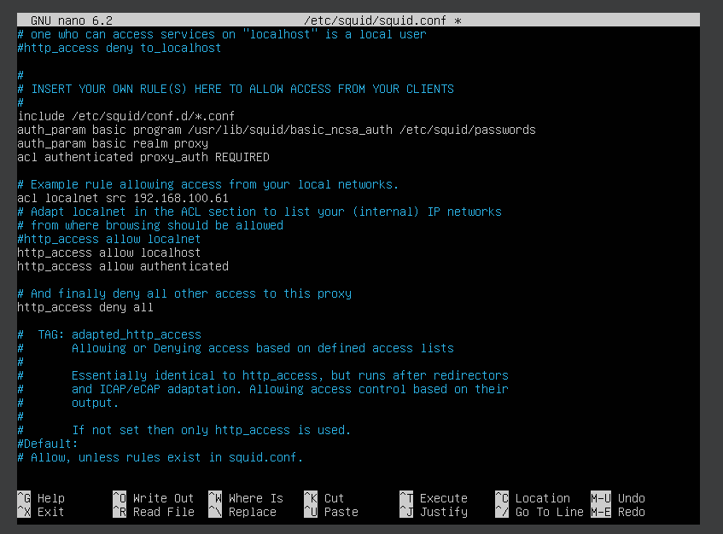

* Restart Squid and open Port 3128 in the firewall:
* /# systemctl restart squid.service
* /# ufw allow 3128
* Connect through Squid using “curl”:
* >curl -v -x

**Install DNS Server on Ubuntu**

* The package name of the DNS Server in the Ubuntu OS is “bind9”:
* /# apt install -u bind9-utils
* Create DNS zones for the domain (Forward Zone and Reverse Zone):
* /# nano /etc/bind/named.conf.local
* Next, create Forward Zone File:
* /# nano /etc/bind/deni.local.db

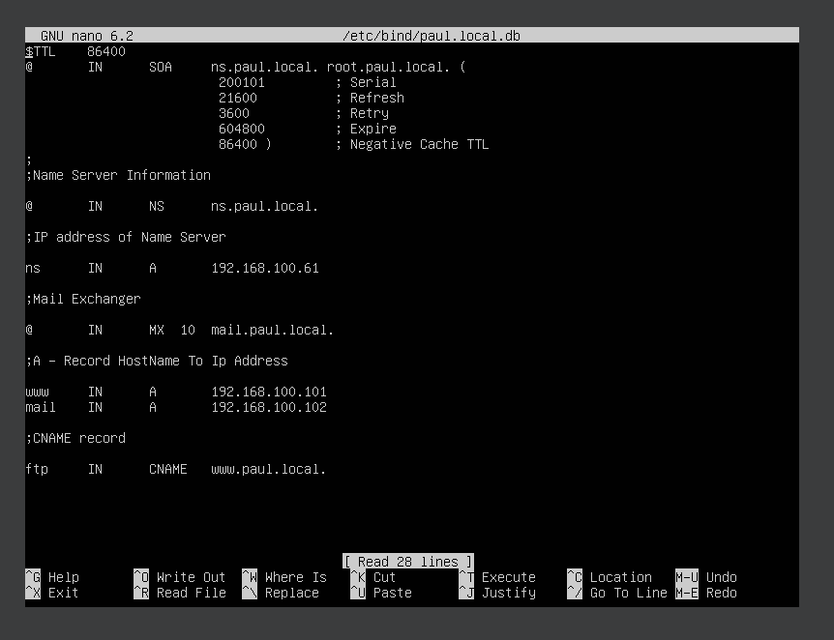

* Also create a Reverse Zone File:
* /# nano /etc/bind/r.deni.local.db
* Validate the DNS Syntax and reload the configuration file and zones:
* /# named-checkzone deni.local /etc/bind/deni.local.db
* /# named-checkzone 100.168.192.in-addr.arpa /etc/bind/r.deni.local.db
* /# rndc reload

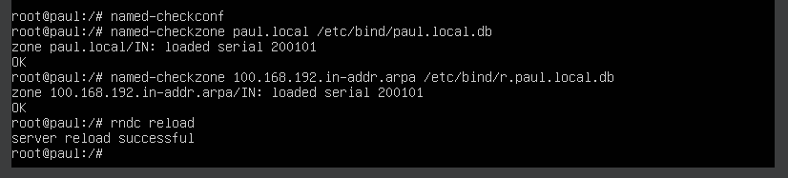

* Verify the DNS Server using “dig”:
* /# dig [www.deni.local](http://www.deni.local) @192.168.100.61

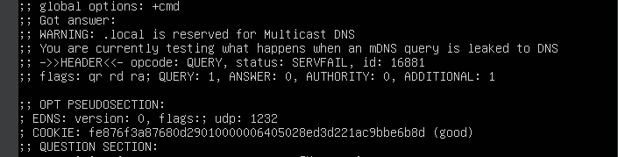

* Confirm the reverse lookup also:
* /# dig -x 192.168.100.101 @192.168.100.61

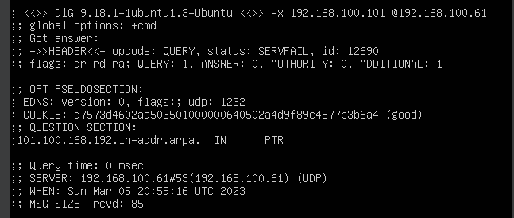

**Install Monit monitoring on Ubuntu**

* Install Monit with the following command:
* /# apt-get install monit
* Check the status:
* /# system ctl status monit
* Next, enable Monit httpd port (2812) on Ubuntu:

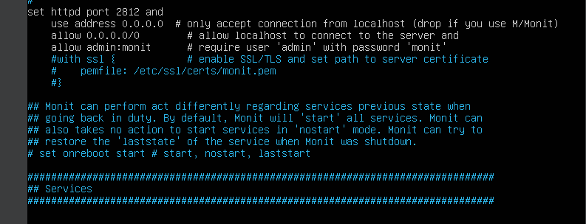

* Check for syntax errors:
* /# monit -t
* Enable Monit Service, restart it and check its status:
* /# /lib/system/system-sysv-install enable monit
* /# systemctl restart monit
* /# monit status
* Allow Monit Port in Ubuntu firewall:
* /# ufw allow 2812
* Now we should be able to access the web interface:

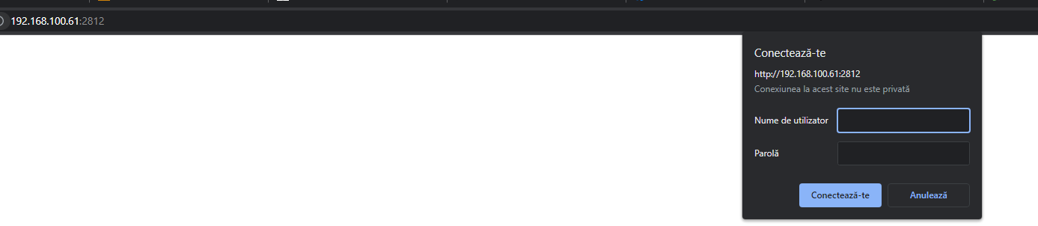

* We can add a new service manually in order to check Monit:
* /# apt install lm-sensors

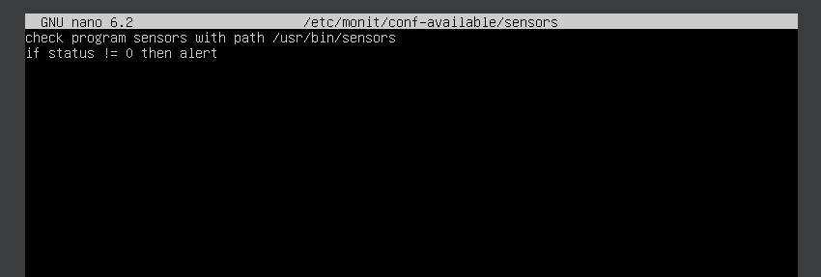

* Enable it:
* /# ln -s /etc/monit/conf-available/sensors /etc/monit/conf-enabled/
* Reload Monit and check its status again:
* /# monit reload
* /# monit status

**Install GoAccess Web Log Analyzer on Ubuntu**

* First, install the required dependencies with the following command:
* /goaccess-1.4# sudo apt install libcursesw5-dev libgeoip-dev libtokyocabinet-dev build-essential
* Next, download the GoAccess source:
* /goaccess-1.4# wget http://tar.goaccess.io/goaccess-1.4.tar.gz
* Extract the downloaded file:
* /goaccess-1.4# tar -xzvf goaccess-1.4.tar.gz
* Change the directory to extracted directory and configure GoAccess:
* /goaccess-1.4# ./configure –enable-utf8 –enable-geoip=legacy
* Install GoAccess to the system using the following commands:
* /goaccess-1.4# make
* /goaccess-1.4# make install
* In order to launch the GoAccess dashbord use:
* /goaccess-1.4# goaccess /var/log/apache2/access.log –log-format=COMBINED

**Secure Ubuntu using Fail2ban**

* Install it with the following command:
* /# apt-get install fail2ban
* Open the configuration file and change the following settings:

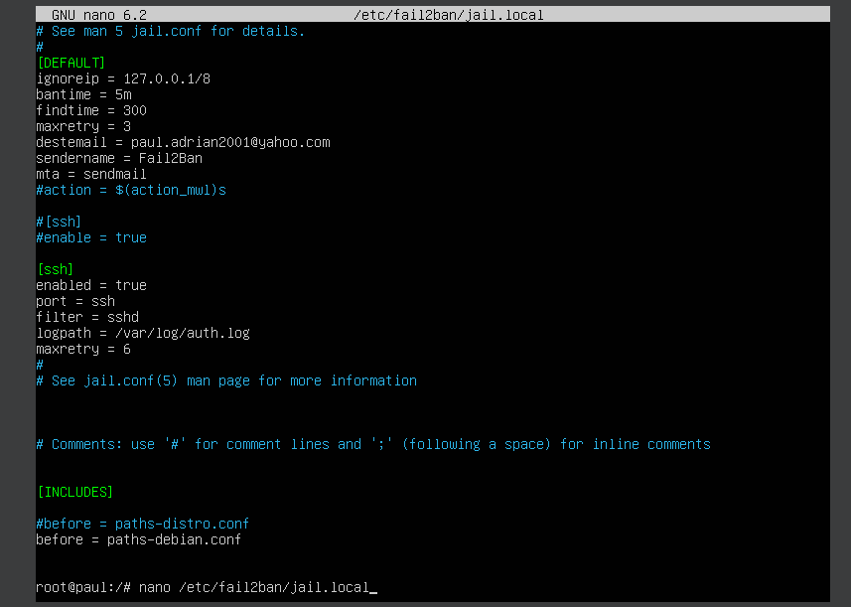

* Restart the service:
* /# service fail2ban restart
* Check the status (also disable firewall using “ufw disable”):
* If for some reason the service fails and it is inactive, we can check the full error logs using “journalctl _PID=XXX” (valid for all services).
* Try some failed SSH login attempts from your machine to check if Fail2ban works.

**Install Docker on Ubuntu**

* Run the following command to install the dependencies:
* /# apt install apt-transport-https curl gnupg-agent ca-certificates software-properties-common -y
* Add the GPGK key:
* /# curl -fsSL <https://download.docker.com/linux/ubuntu/gpg> | sudo apt-key add-
* Add the Docker repository:
* /# add-apt-repository “deb [arch=amd64] <https://downlaod.docker.com/linux/ubuntu> focal stable”
* Install Docker and the associated packages:
* /# apt install docker-ce docker-ce-cli conrainerd.io -y
* Add the current user to the docker group and confirm that Docker is installed:
* /# usermod -Ag docker $USER
* /# newgrp docker
* /# docker version
* Verify that Docker is started:
* /# systemctl status docker
* Test Docker by pulling a “hello-world” image from Docker Hub:
* /# docker run hello-world
* Confirm the images on the system:
* /# docker images